**ENGG1330**

**Group Project**

**Group 1A-5**

Project theme: Aeroplane chess

Group members: (Team Leader *)

1. Chen Pengxu (3036094992)
2. Cheung Man Hei Kay (3036106109)
3. Leung Wang Kin* (3036068539)
4. Oyolo Frankline Misango (3036050867)

Highlight (gameplay):

1. We have an ASCII art for a welcome screen.



1. Our game is consciously designed and optimized for a maximized terminal, with small but significant modifications to enhance player experience, such as centering the game board as well as designing round information such that it minimizes distraction and cognitive load for players during a game.

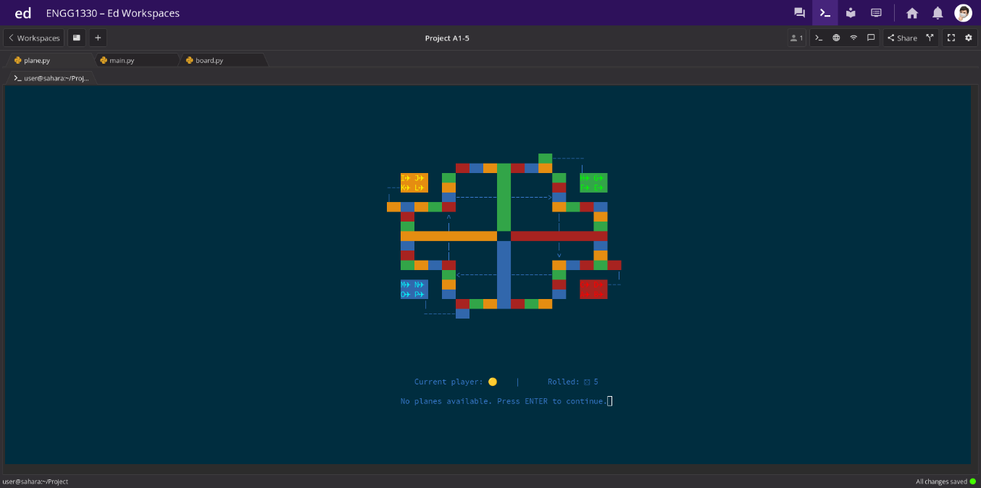



1. We colored the text and background of the game to recreate the authentic and iconic Aeroplane Chess experience.



1. We make use of the clear screen function to mimic looking at the same, continually updated screen, minimizing disruption to the player experience.

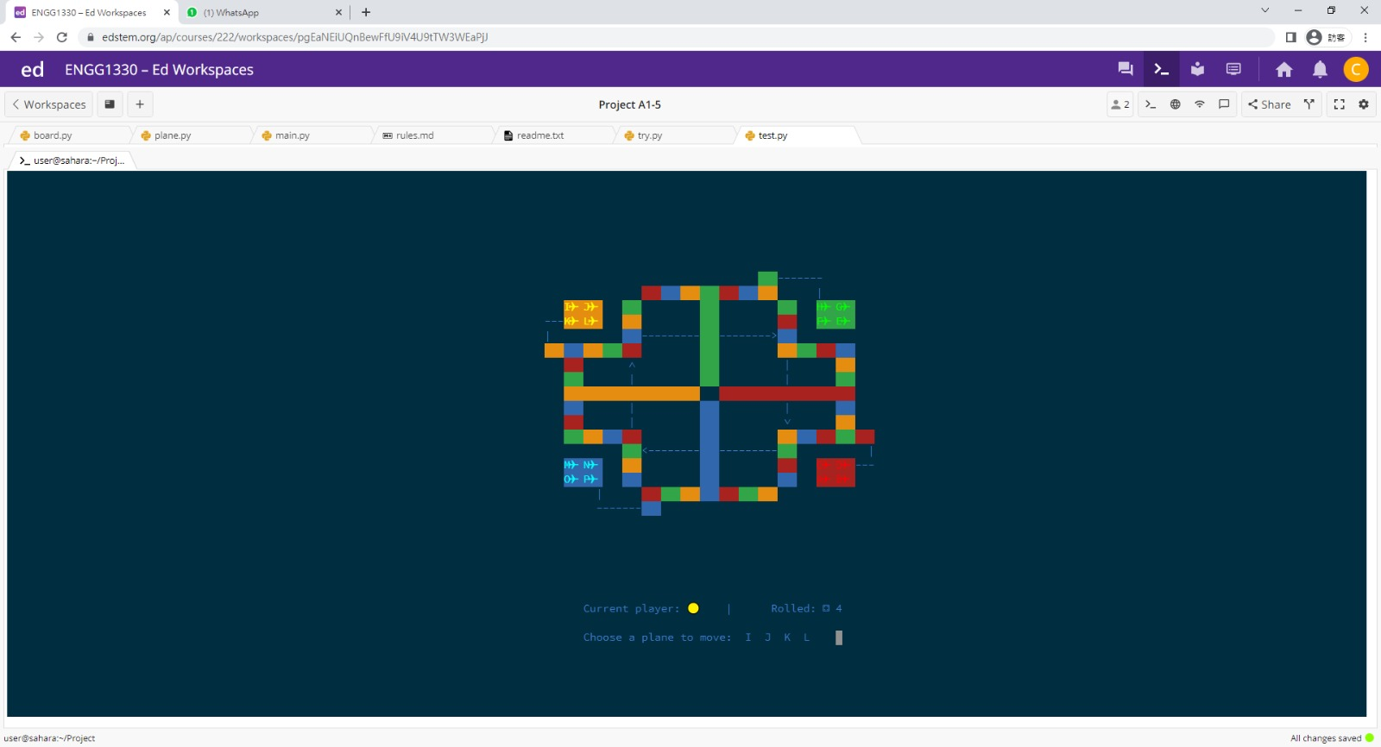



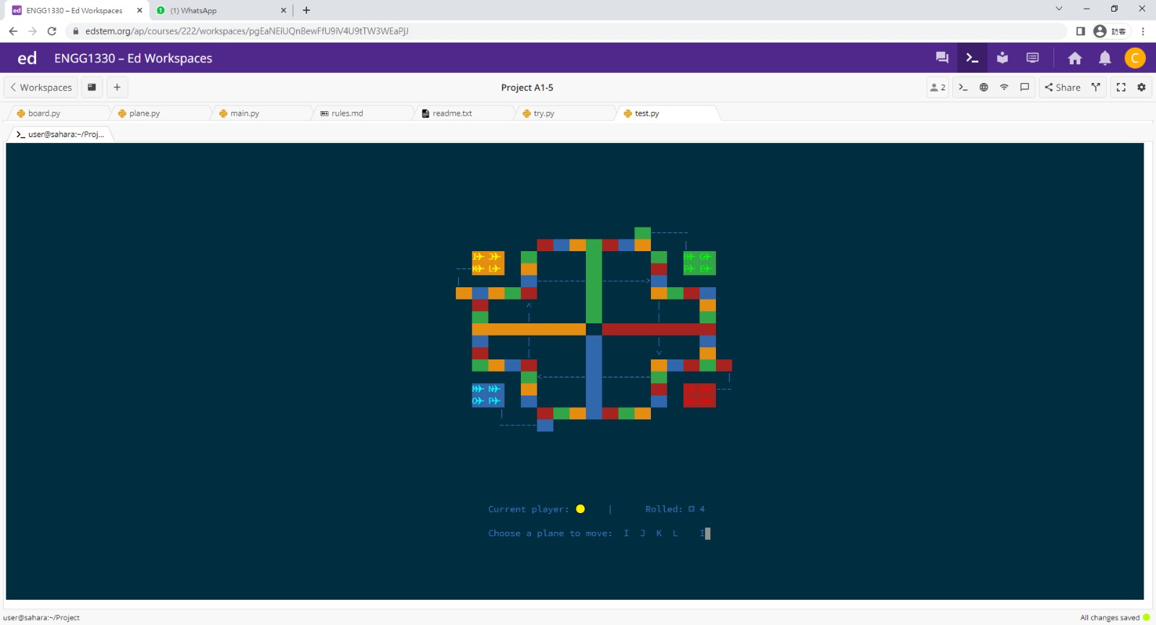



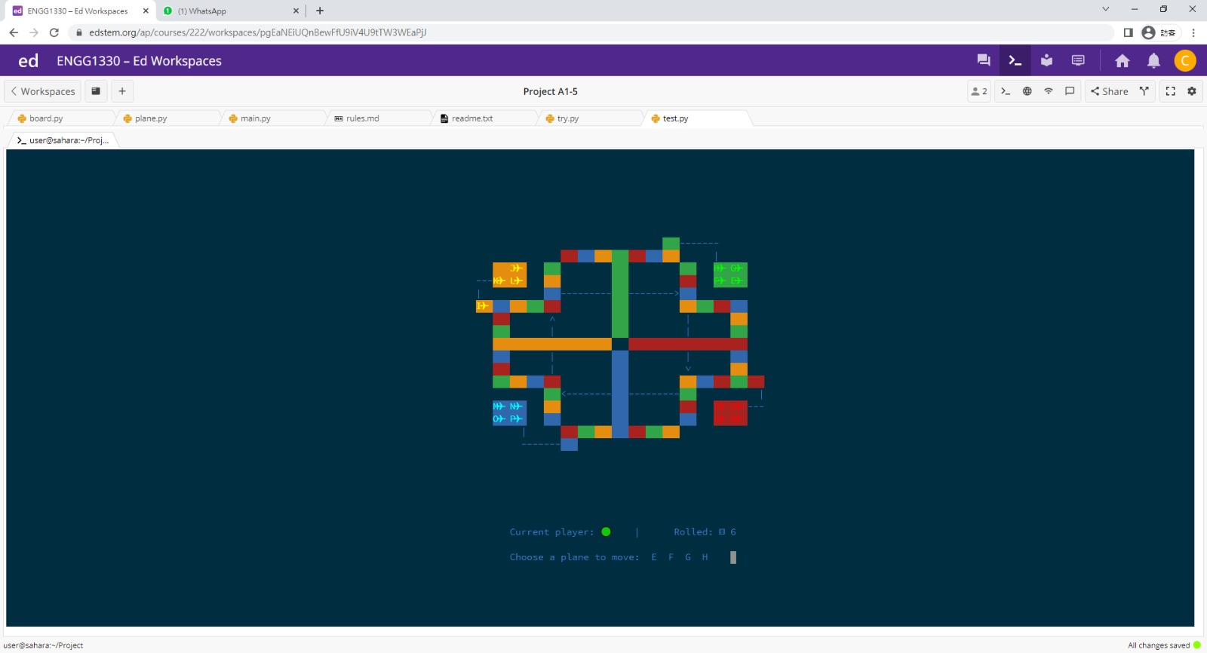

1. Attacking an opponent’s plane

If a player's plane lands on a space occupied by another player's plane, that plane takes the place of the other player's plane, which is sent back to the hanger and waits to take off again.



7. Jump

When a player's plane lands on a space of the same colour as his own, the plane jumps to the next space of the same colour as his own.

i.e. the plane moves four spaces forward.



8. Handling invalid input

If the player enters an invalid input, the system will ignore the current input and ask the player to enter a new input again until a valid input is given.

9. Only available planes will be shown as an option

After each die roll, the system will remind you which planes can be moved. If no aircraft can be moved, then the system will tell you “No planes available, press ‘Enter’ to continue”.

Planes cannot move to the launchpad if there’s already a plane there

10. Super jump

When a player's plane lands on a super jump point of its own colour, the plane super jumps by following the dotted line shown on the board to the space across the board, by 12 spaces forward.

